## Visualizing and Predicting Heart Diseases with an Interactivate Dashboard

**Submitted By**

**Team ID : PNT2022TMID18098**

**Team Leader : Dhanabhagya.S**

**Team member : Sowmya.S**

**Team member : Jayashree.P**

**Team member : Pavithra.KA**

# Project Report

#### INTRODUCTION

* 1. Project Overview
  2. Purpose

#### LITERATURE SURVEY

* 1. Existing problem
  2. References
  3. Problem Statement Definition

#### IDEATION & PROPOSED SOLUTION

* 1. Empathy Map Canvas
  2. Ideation & Brainstorming
  3. Proposed Solution
  4. Problem Solution fit

#### REQUIREMENT ANALYSIS

* 1. Functional requirement
  2. Non-Functional requirements

#### PROJECT DESIGN

* 1. Data Flow Diagrams
  2. Solution & Technical Architecture
  3. User Stories

#### PROJECT PLANNING & SCHEDULING

* 1. Sprint Planning & Estimation
  2. Sprint Delivery Schedule
  3. Reports from JIRA

#### CODING & SOLUTIONING

1. **TESTING**
   1. Test Cases
   2. User Acceptance Testing

#### RESULTS

* 1. Performance Metrics **10.ADVANTAGES & DISADVANTAGES 11.CONCLUSION**

#### FUTURE SCOPE

1. **APPENDIX**

**CHAPTER 1**

# INTRODUCTION

### 1.PROJECT OVERVIEW:

The terms **"heart disease"** and **"cardiovascular disease"** are frequently used interchangeably. Heart disease is a general term that coverage of heart-related medical conditions. These medical conditions characterize the irregular health state that directly affects the heart and its components.

In order to forecast cardiac disease, this study discusses various data mining, big data, and machine learning techniques. Building an important model for the medical system to forecast heart disease or cardiovascular illness requires the use of data mining and machine learning. Our application helps the user find out if they have heart disease.

They can find out by entering details such as their heart rate, cholesterol, blood pressure, etc. A dashboard is also attached along with the results for a better understanding of where they can compare their blood pressure and similar metrics with other users. This project focuses on Random Forest Classifier. The accuracy of our project 87% is for which is better than most other systems in terms of achieving accuracy quickly.

### 2.PURPOSE:

This project's goal is to determine, depending on the patient's medical characteristics such as gender, age, chest pain, fasting blood sugar level, etc…whether they are likely to be diagnosed with any cardiovascular heart illnesses. The leading cause of death in the developed world is heart disease. Heart disease cases are rising quickly every day, thus it's crucial and worrisome to predict any potential illnesses in advance. This diagnosis is a challenging task that requires accuracy and efficiency.

Therefore, work must be done to help prevent the risks of a heart attack or stroke. It is the main factor in adult deaths. By using a person's medical history, our initiative can identify those who are most likely to be diagnosed with

a cardiac condition. It can assist in identifying diseases with fewer medical diseases and effective therapies so that patients can be treated appropriately. It can identify anyone who is experiencing any heart disease symptoms, such as chest pain or high blood pressure.

Around the world, machine learning is applied in many different fields. There is no exception in the healthcare sector. Machine learning may be crucial in determining whether locomotor disorders, heart illnesses, and other conditions are present or absent. If foreseen well in advance, such information can offer valuable insights to doctors, who can then customize their diagnosis and course of care for each patient.

# CHAPTER 2

## LITERATURE SURVEY

### EXISTING PROBLEM

### The diagnosis of heart disease in most cases depends on a complex combination of clinical and pathological data. Because of this complexity, there exists a significant amount of interest among clinical professionals and researchers regarding the efficient and accurate prediction of heart disease. In this paper, develop a heart disease prediction system that can assist medical professionals in predicting heart disease status based on the clinical data of patients. These approaches include three steps. Firstly, select 13 important clinical features, i.e., age, sex, chest pain type, trest bps, cholesterol, fasting blood sugar, resting ECG, max heart rate, exercise-induced angina, old peak, slope, and the number of vessels colored. Secondly, develop an artificial neural network algorithm for classifying heart disease based on these clinical features. The accuracy of prediction is near 80%. Finally, develop a user-friendly heart disease prediction system (HDPS). The HDPS system will consist of multiple features, including an input clinical data section, an ROC curve display section, and prediction performance display section (execute time, accuracy, sensitivity, specificity, and predict result). Our approaches are effective in predicting the heart disease of a patient. The HDPS system developed in this study is a novel approach that can be used in the classification of heart disease.

### REFERENCES:

1. C. Sowmiya and P. Sumitra, "Analytical study of heart disease diagnosis using classification techniques," 2017
2. IEEE International Conference on Intelligent Techniques in Control, Optimization and Signal Processing (INCOS), 2017, pp. 1-5, doi: 10.1109/ITCOSP.2017.8303115.
3. J. Thomas and R. T. Princy, "Human heart disease prediction system using data mining techniques," 2016, International Conference on Circuit, Power and Computing Technologies (ICCPCT), 2016, pp. 1-5,doi: 10.1109/ICCPCT.2016.7530265.
4. M. S. Raja, M. Anurag, C. P. Reddy and N. R. Sirisala, "Machine Learning Based Heart Disease Prediction System," 2021 International Conference on Computer Communication and Informatics (ICCCI), 2021, pp. 1- doi: 10.1109/ICCCI50826.2021.9402653.
5. N. M. Lutimath, N. Sharma and B. K. Byregowda, "Prediction of Heart Disease using Random Forest," 2021Emerging Trends in Industry 4.0 (ETI 4.0), 2021, pp. 1-4, doi: 10.1109/ETI4.051663.2021.9619208.
6. G. N. Ahmad, H. Fatima, S. Ullah, A. Salah Saidi and Imdadullah, "Efficient Medical Diagnosis of Human Heart Diseases Using Machine Learning Techniques With and Without GridSearchCV," in IEEE Access, vol. 10, pp. 80151-80173, 2022, doi: 10.1109/ACCESS.2022.3165792.
7. J. P. Li, A. U. Haq, S. U. Din, J. Khan, A. Khan and A. Saboor, "Heart Disease Identification Method Using Machine Learning Classification in E-Healthcare," in IEEE Access, vol. 8, pp. 107562-107582, 2020,doi: 10.1109/ACCESS.2020.3001149.
8. A. H. Chen, S. Y. Huang, P. S. Hong, C. H. Cheng and E. J. Lin, "HDPS: Heart disease prediction system," 2011 Computing in Cardiology, 2011, pp. 557-560.
9. F. Demir, A. Şengür and M. Çavaş, "HEART SOUNDS CLASSIFICATION WITH DEEP FEATURES ANDSUPPORT VECTOR MACHINES," 2018 International Conference on Artificial Intelligence and Data Processing (IDAP), 2018, pp. 1-5, doi: 10.1109/IDAP.2018.8620733.
10. T. Feng, H. Tang, M. Wang, C. Zhang, H. Wang and F. Cong, "Continuous Estimation of Left Ventricular Hemodynamic Parameters Based on Heart Sound and PPG Signals Using Deep Neural Network," 2020 International Conference on Sensing, Measurement & Data Analytics in the era of Artificial Intelligence (ICSMD), 2020,pp. 313-318, doi: 10.1109/ICSMD50554.2020.9261681.
11. 10. M. Chourasia, A. Thakur, S. Gupta and A. Singh, "ECG Heartbeat Classification Using CNN," 2020 IEEE 7th Uttar Pradesh Section International Conference on Electrical, Electronics and Computer Engineering (UPCON), 2020, pp. 1-6, doi: 10.1109/UPCON50219.2020.9376

#### CHAPTER 3

#### IDEATION & PROPOSED SOLUTION

#### 1.EMPATHY MAP CANVAS

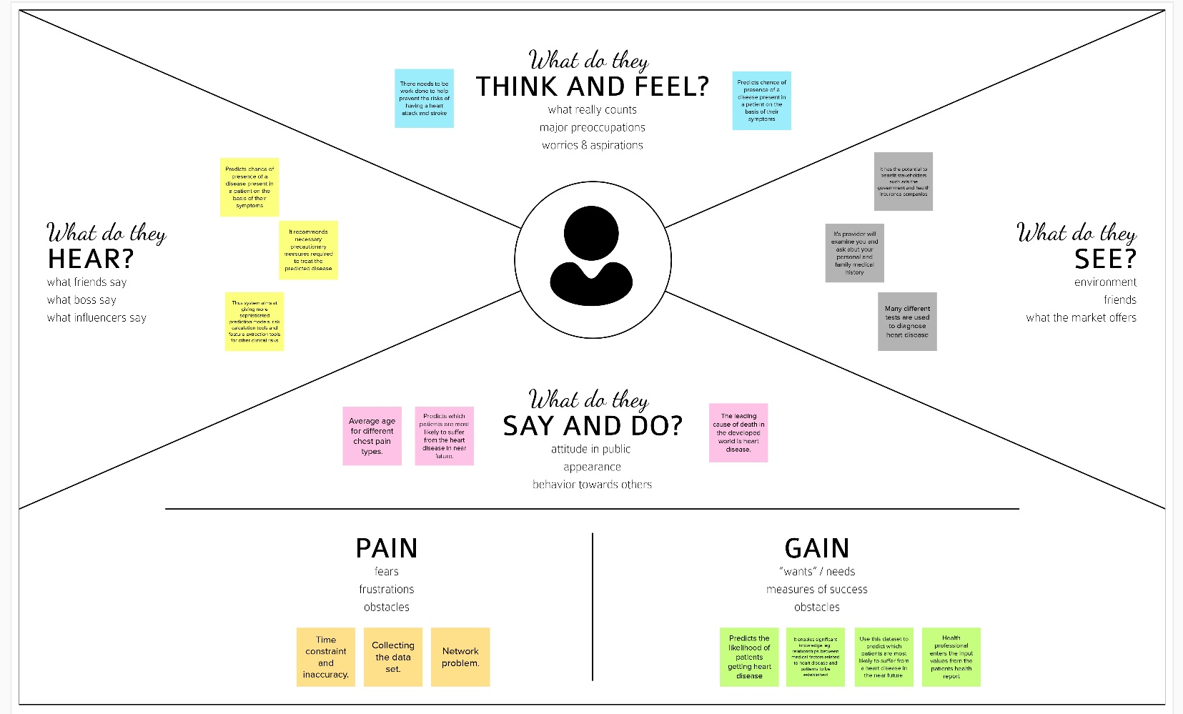

### 2.PROPOSED SOLUTION

|  |  |  |
| --- | --- | --- |
| **S.No** | **Parameter** | **Description** |
| **1.** | Problem Statement (Problem to be solved) | The leading cause of death is heart disease. Heart disease refers to several types of abnormalities in heart conditions. It is inconvenient for a common man to take ECG tests periodically. Also, lack of proper diagnostic tools and accurate results affect the treatment of cardiac patients Thus based on a patient's medical history, an expert's symptom analysis report, and physical laboratory results, invasive procedures are used to identify heart related problems. And so, there is a need for a replacement, which must be less complicated and reliable. The goal is to come up with a reliable prediction model so that the hospital can use this information to treat the patients at the starting state of the disease. |
| **2.** | Idea / Solution description | The solution is to provide an interactive dashboard for visualising and predicting cardiac problems. IBM Cognos platform is used to visualize the given data. Machine learning techniques like Support Vector Machine, Decision tree, Naive Bayes, Random forest, K-Nearest Neighbour, and Neural networks are used to predict cardiac disease. To achieve greater accuracy, fusion of these algorithms is done. Exploratory Data Analysis (EDA) is a method to analyse data using advanced techniques to expose hidden structure, enhance the insight into a given dataset, identify the anomalies and build parsimonious models to test the underlying assumptions. The parameters provided in the data set help hospitals identify the patient's heart condition. An informative and creative dashboard can be created to present the data and utilize it for further medications. |
| **3.** | Novelty / Uniqueness | The prime novelty of the solution is the fusion of highly efficient algorithms, that eliminates the disadvantage of every algorithm when employed individually and also provides a higher leb=vel of accuracy in the prediction. Another innovation is employed in the dashboard by providing diet and fitness related suggestions to the user based on his/her medical reports and history. In addition to it, the patient is given a list of hospitals closer to the patient’s locality and severity of the disease. |
| **4.** | Social Impact / Customer Satisfaction | It helps with disease prediction at an early stage and alerts the user about his/her current health status. Heart disease can be cured by a mix of medication, lifestyle modifications, and occasionally, surgery. The system helps the user as well as the doctor to make better decisions. Complex questions related to heart diseases can be answered by extracting hidden knowledge, i.e., patterns and relationships from the heart disease database. |
| **5.** | Business Model (Revenue Model) | ● This interactive dashboard for heart disease prediction can be installed in hospitals and healthcare facilities. Predicted outcomes can be utilised to avoid expensive surgeries.  ● It can be used in educational institutions, industries and all types of workplaces to monitor the employees’ health conditions and thereby helping them lead a healthier life. |
| **6.** | Scalability of the Solution | ● The proposed solution works efficiently in both smaller and larger datasets.  ● This predictive model can be used to detect diseases in other internal organs too. |

**3.PROBLEM SOLUTION FIT**

The Problem-Solution Fit simply means that we have found a problem with our customer and that the solution we have realized for it actually solves the customer’s problem. It helps entrepreneurs, marketers and corporate innovators identify behavioral patterns and recognize what would work and why. The purpose is to solve complex problems in a way that fits the state of your customers and succeed faster and increase your solution adoption by tapping into existing mediums and channels of behaviour

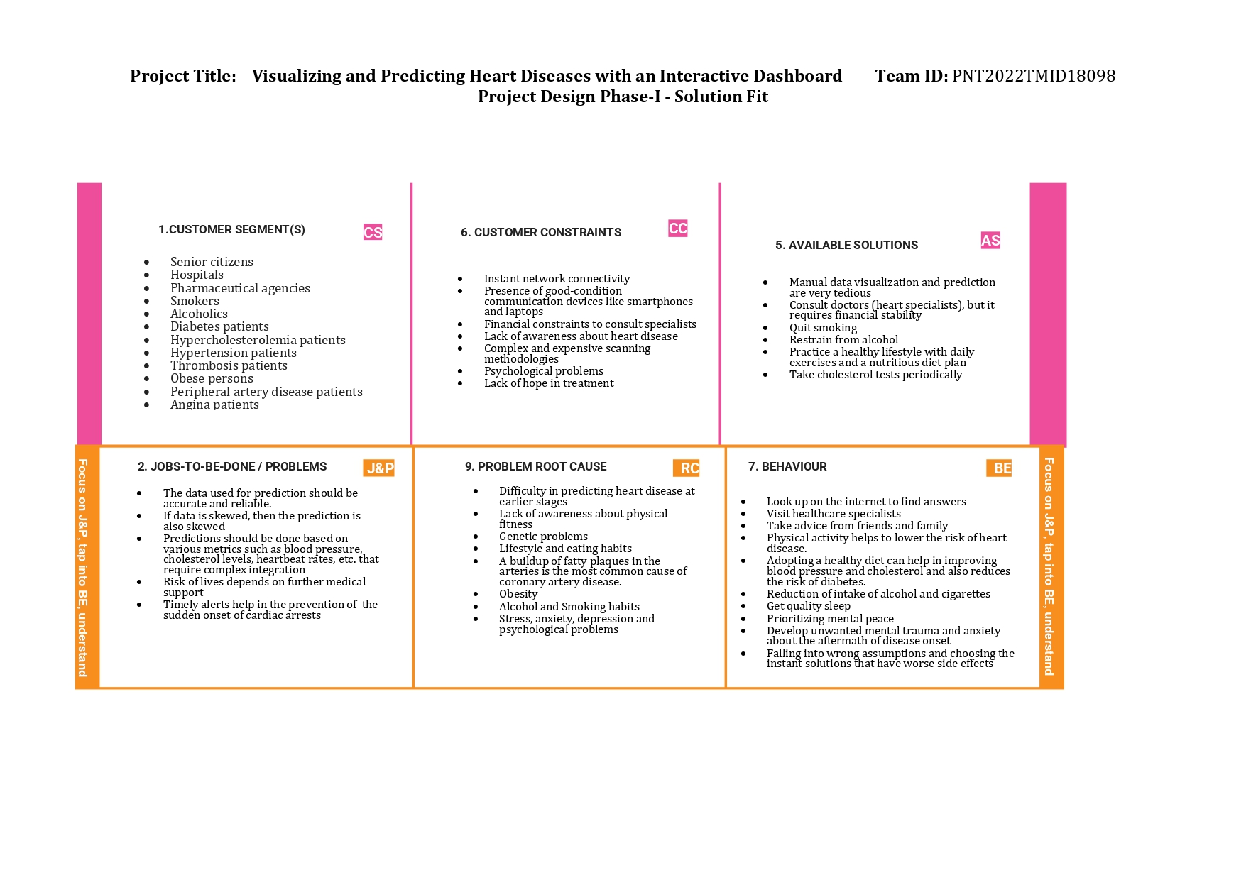

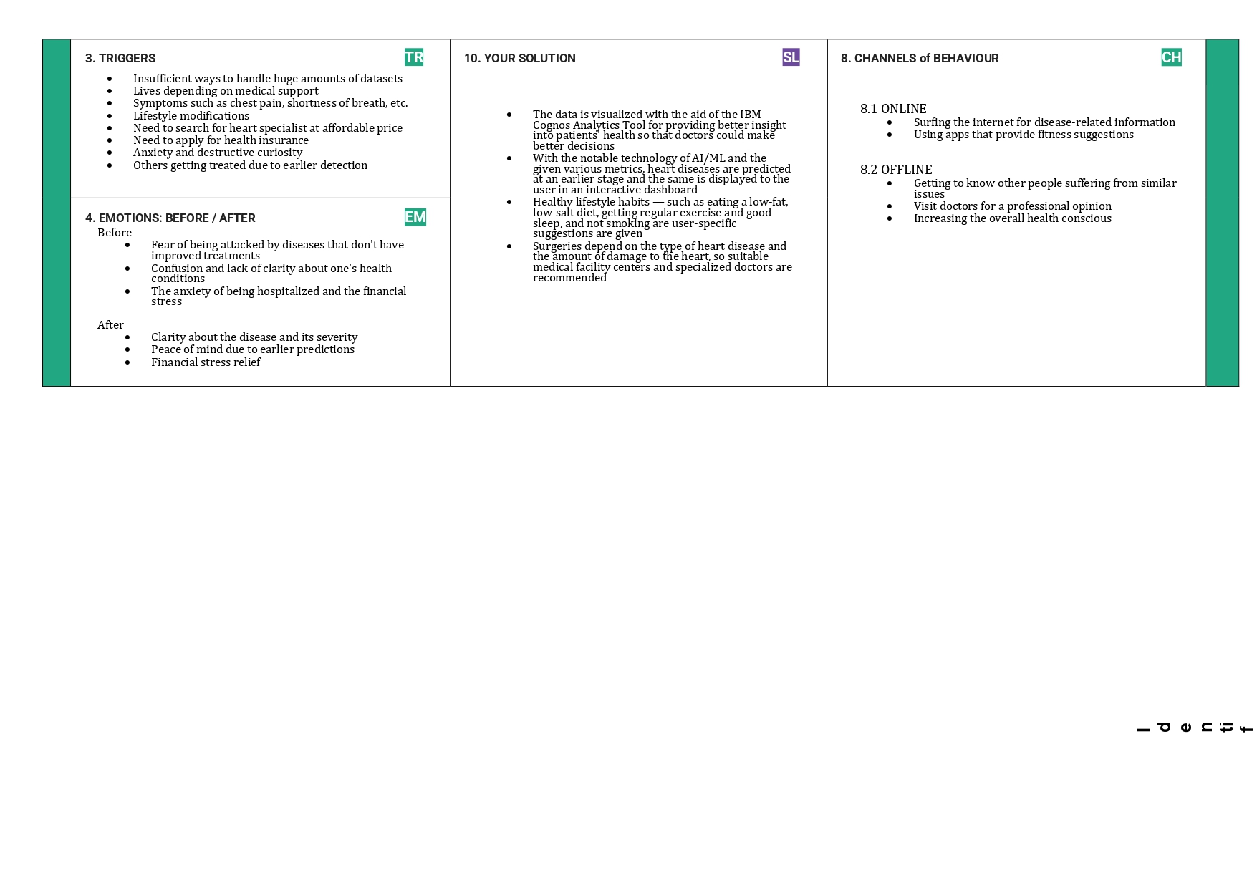

**CHAPTER 4**

## REQUIREMENT ANALYSIS

**1.FUNCTIONAL REQUIREMENTS**

|  |  |  |
| --- | --- | --- |
| **FR No.** | **Functional Requirement (Epic)** | **Sub Requirement (Story / Sub-Task)** |
| FR-1 | **User Registration** | Enables users to make registration through a Google account, phone number, and online application forms. |
| FR-2 | **User Confirmation** | Confirmation mail or message is sent to the user immediately after registration. |
| FR-3 | **User’s present status updation** | Gets the user’s important medical conditions like heart beat rate, blood pressure, blood sugar level and cholesterol level. |
| FR-4 | **Data Visualization** | The present medical status of the patient is visualized for better interpretation using IBM Cognos Analytics. |
| FR-5 | **Disease Prediction** | Uses advanced machine learning techniques to predict the presence or absence of a heart disease and also its type if the disease is present. |

**2. NON-FUNCTIONAL REQUIREMENTS**

|  |  |  |
| --- | --- | --- |
| **FR No.** | **Non-Functional Requirement** | **Description** |
| NFR-1 | **Usability** | * Easier navigation boosts the entire product's usability, helping users enjoy all the features offered. * Our solution has better characteristics in navigation such as a hamburger menu. * The application has a simple and userfriendly graphical interface. * Any action can be performed with just a few clicks. * Gives a tour regarding the features of the dashboard for first-time users. |
| NFR-2 | **Security** | * The website does not require additional cookies to offer services. * It stores the data of the patients in a protected database. * It confirms the user’s identity before any prediction is disclosed. * It does not allow another app or site to access data unless we intend to send data from the database to a different app or site that we don't own. * It provides data to the intended recipients as customized by each user personally. |
| NFR-3 | **Reliability** | * The dashboard is accessible 24 x 7 * It responds within the time frame needed. * It is regularly updated as per the user requirements. * The proposed solution provides a high degree of accuracy in the prediction of diseases. |
| NFR-4 | **Performance** | * The dashboard provides real-time notifications about the user condition to the intended users. * The proposed solution offers services such as disease prediction, prevention, and treatment. * Due to the employment of lightweight algorithms, the speed of performance of the prediction modal is high. |
| NFR-5 | **Availability** | * The application is available 24 x 7 for users without any interruption. * The user can access the application anytime, anywhere. * The data is spread across clusters so that if one storage node fails the entire data is not lost. |
| NFR-6 | **Scalability** | * Any number of users can use the prediction model accurately without any delay at the same time using this application. * It can be integrated with smartwatches and apps for further advancements. |

## CHAPTER 5 PROJECT DESIGN

### 1.Data Flow Diagrams, Solution & Technical Architecture

**Data Flow Diagrams:**

A Data Flow Diagram (DFD) is a graphical representation of the flow of data in a business information system. It describes the processes that are involved in a system to transfer data from the input to the file storage and reports generation. It shows how data enters and leaves the system, what changes the information, and where data is stored.

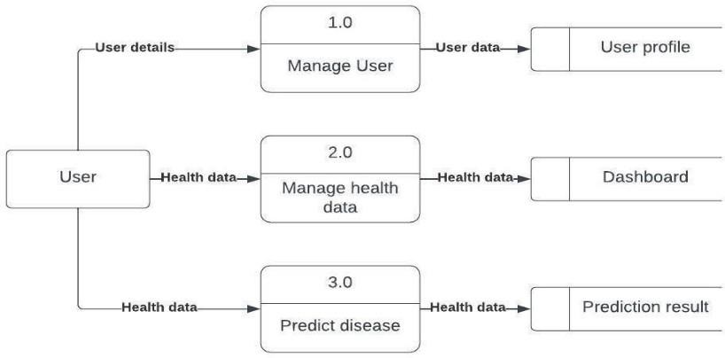

#### 2.Solution and Architecture diagram:

Solution architecture is a complex process with many sub-processes that bridges the gap between business problems and technology solutions. Its goals are to:

* + - Find the best tech solution to solve existing business problems.
    - Describe the structure, characteristics, behavior, and other aspects of the software to project stakeholders.
    - Define features, development phases, and solution requirements.
    - Provide specifications according to which the solution is defined, managed, and delivered.

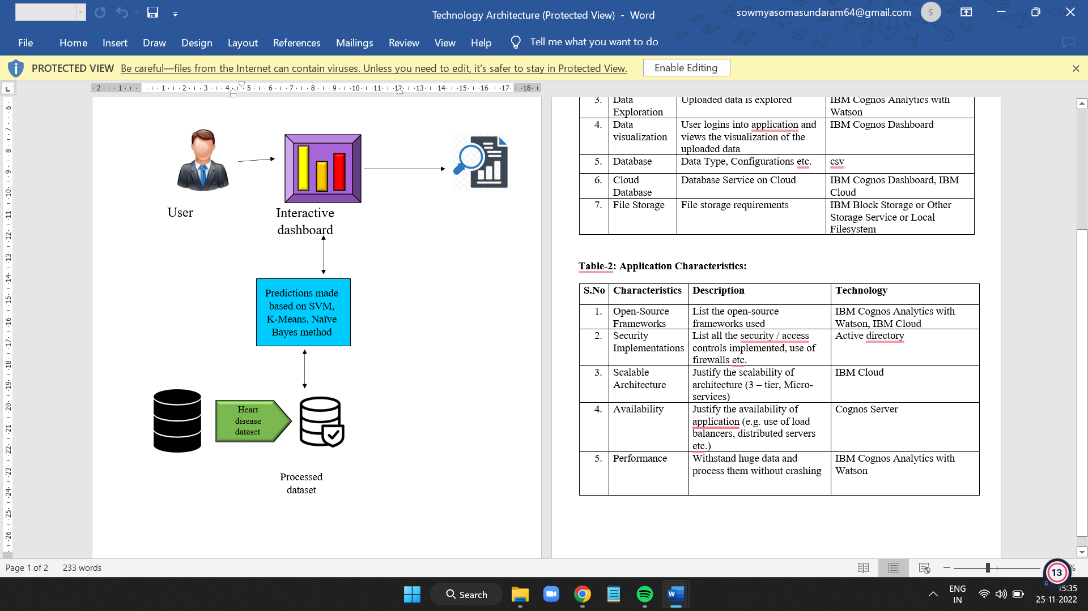

**3. USER STORIES**

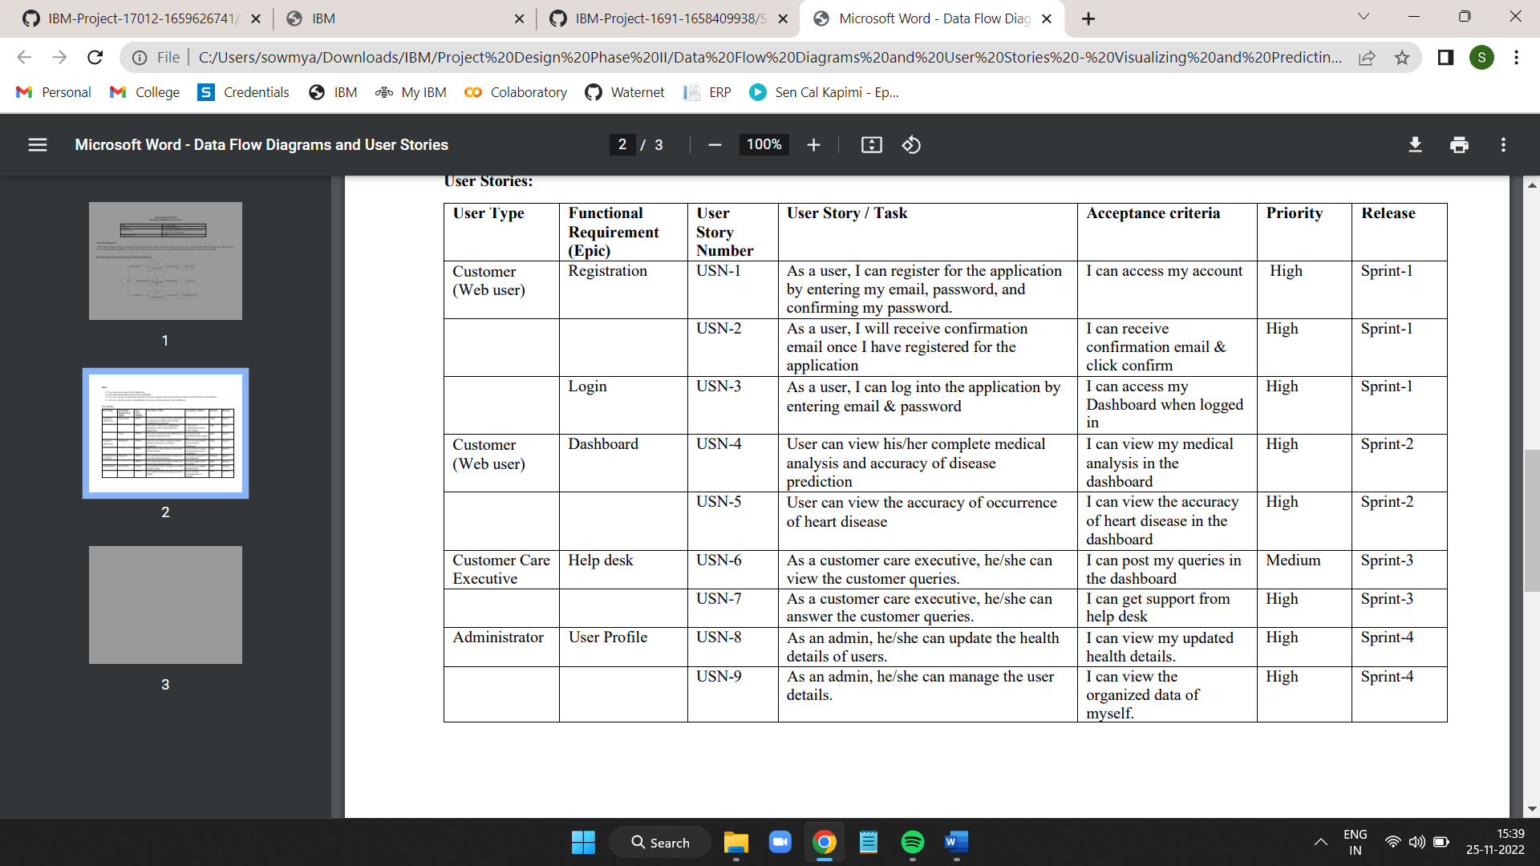

#### CHAPTER 6

#### PROJECT PLANNING & SCHEDULING

* 1. SPRINT PLANNING & ESTIMATION

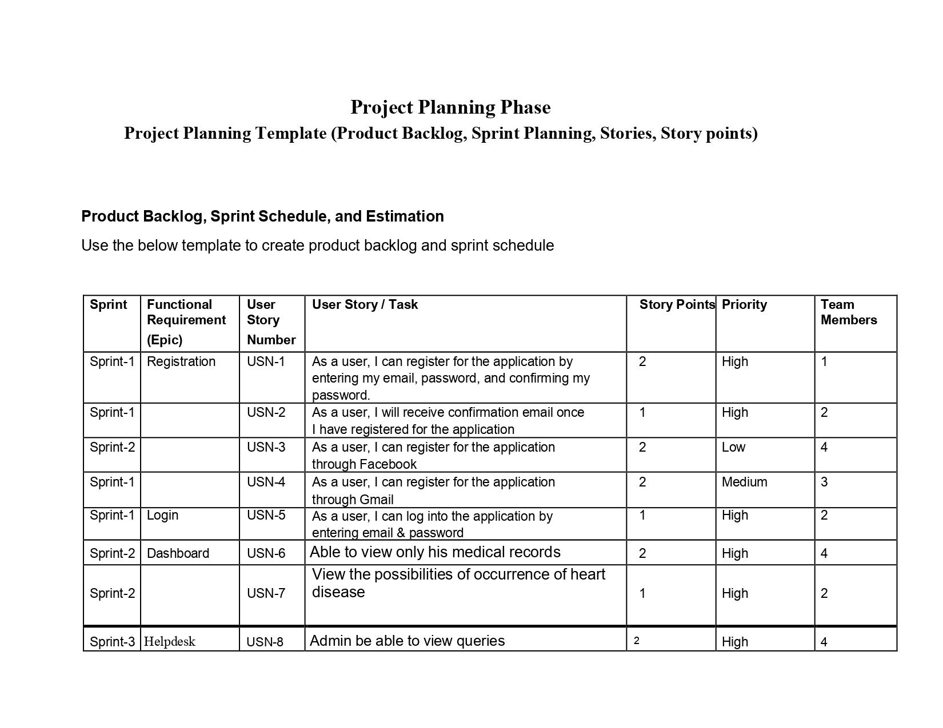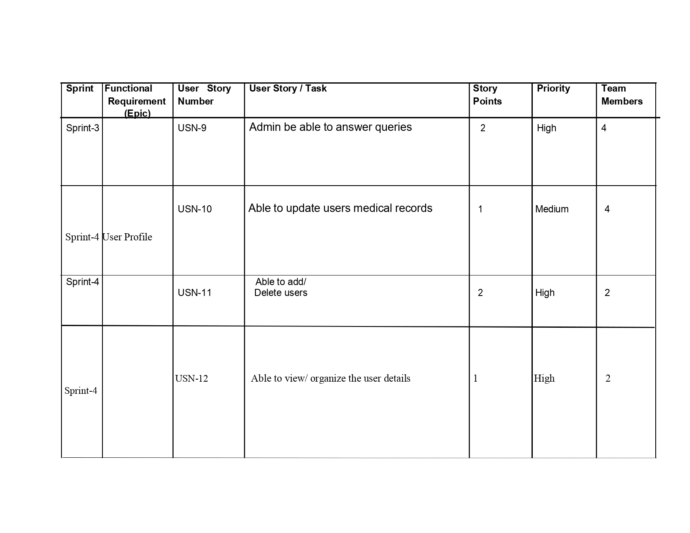

**3.BURNDOWN CHART:**

A burn down chart is a graphical representation of work left to do versus time. It is often used in agile software development methodologies such as Scrum. However, burn down charts can be applied to any project containing measurable progress over time.

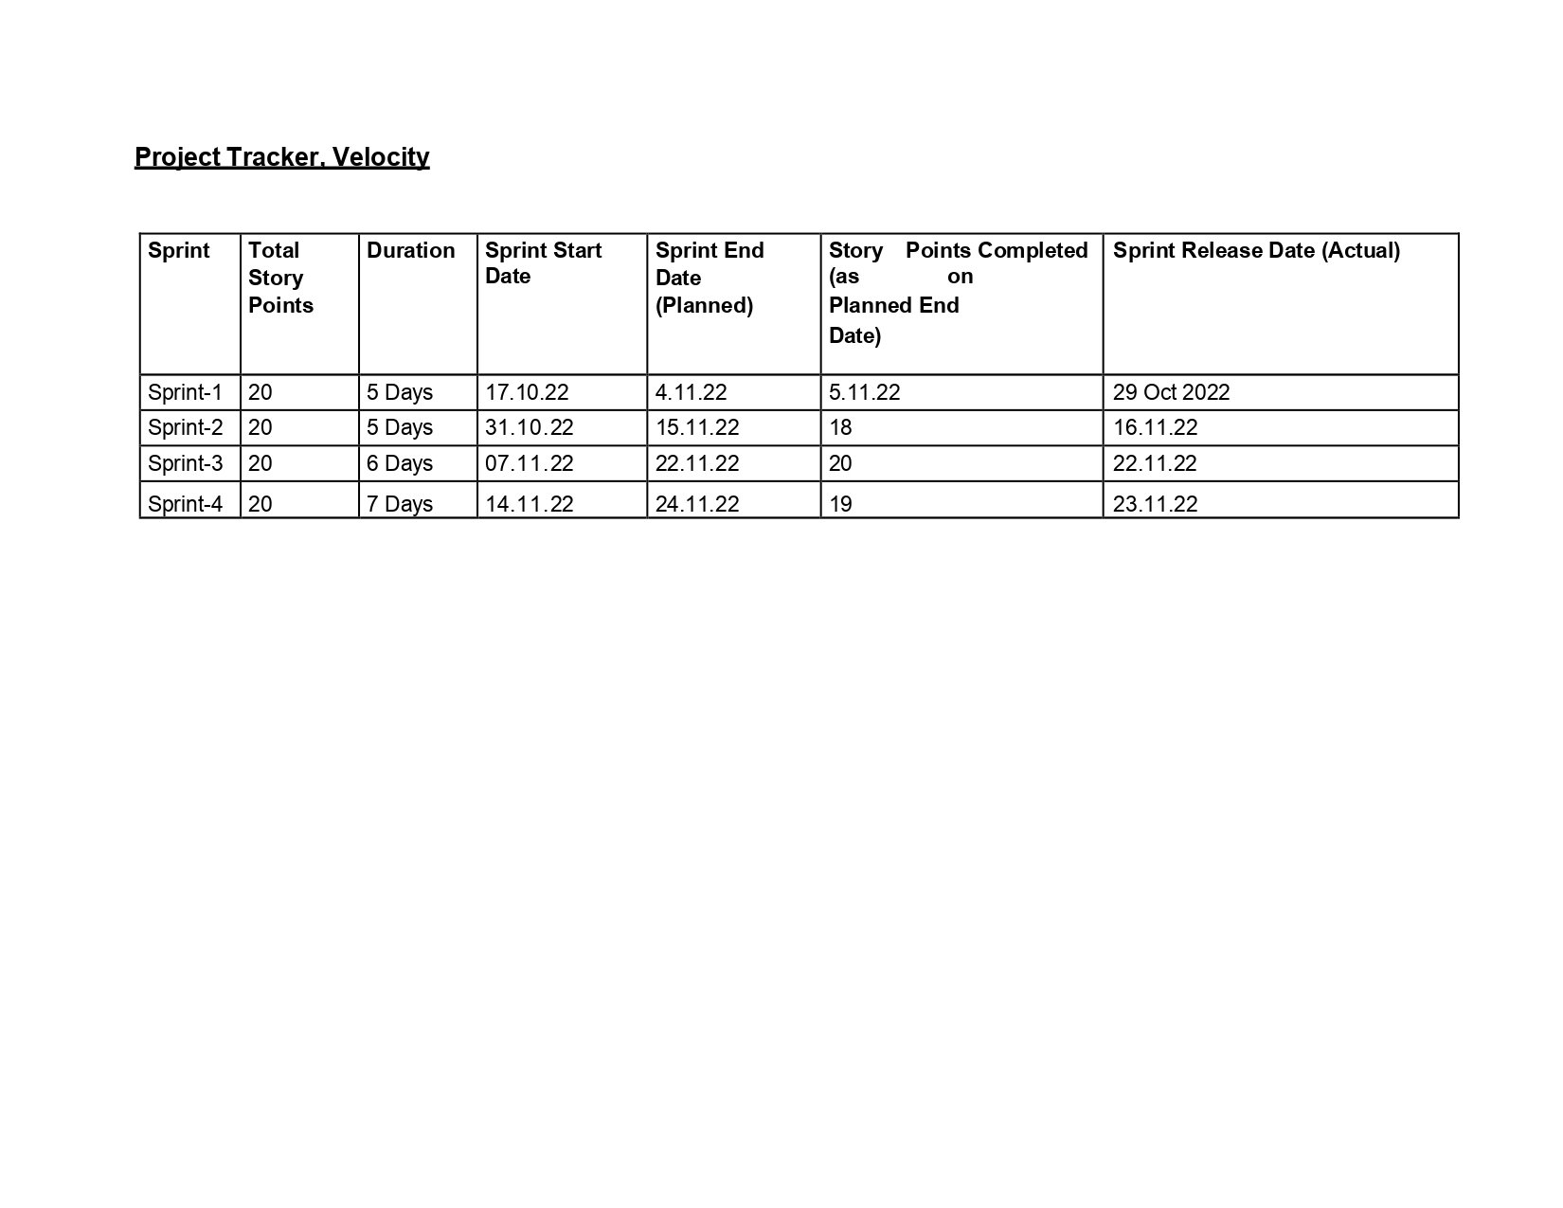

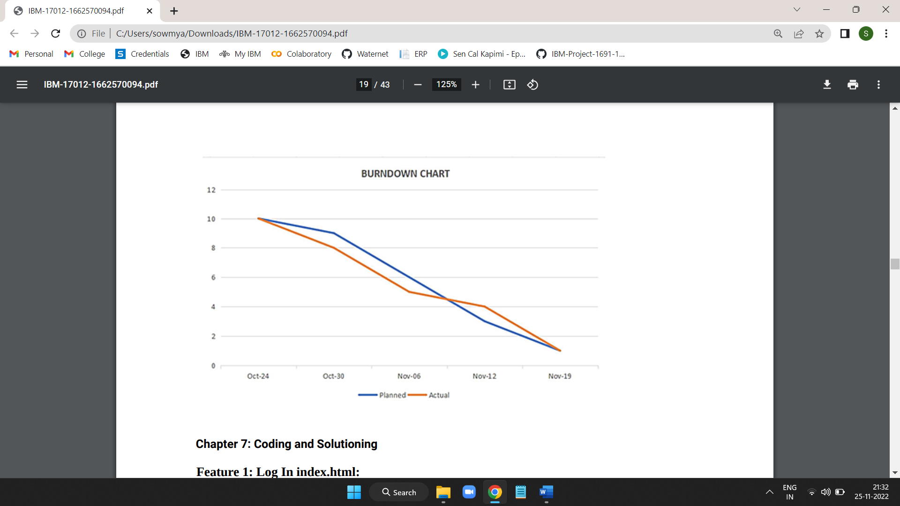

**Velocity:**

Imagine we have a 5-day sprint duration, and the velocity of the team is 10 (points per sprint).

Let’s calculate the team’s average velocity (AV) per iteration unit (story points per day)

AV=Sprint Duration/Velocity=10/5=2

#### CHAPTER 7

#### CODING & SOLUTIONING

**Feature 1: Login Index.html:**

|  |  |
| --- | --- |
|  | |
|  | {%extends home.html}  {% block title %} | |
|  | {{title}} | |
|  | {% endblock title %} | |
|  | {% block content %} | |
|  | {% if succ %} | |
|  |  | |
|  | <div class="hero"> | |
|  | <p class="alert alert-success" role="alert" style="z-index:1;">{{ succ }} | |
|  | </p> | |
|  | <br> | |
|  |  | |
|  | <h1>Heart Disease Prediction</h1> | |
|  | </div> | |
|  |  | |
|  |  | |
|  | {% else %} | |
|  | <div class="hero"> | |
|  | <div class="container-n"> | |
|  | <p class = "para" >Cardiovascular diseases (CVDs) are the leading cause of death globally, taking an estimated  17.9 million lives each year. CVDs are a group of disorders of the heart and blood vessels and include coronary heart disease, cerebrovascular disease, rheumatic heart disease and other conditions. More than four out of five CVD deaths  are due to heart attacks and strokes, and one third of these deaths occur prematurely in people under 70 years of age. | |
|  |  | |
|  | The most important behavioural risk factors of heart disease and stroke are unhealthy diet, physical inactivity,  tobacco use and harmful use of alcohol. The effects of behavioural risk factors may show up in individuals as raised  blood pressure, raised blood glucose, raised blood lipids, and overweight and obesity. These “intermediate risks  factors” can be measured in primary care facilities and indicate an increased risk of heart attack, stroke,  heart failure and other complications. </p> | |
|  | <br> | |
|  | </div> | |
|  | </div> | |
|  |  | |
|  | {% endif %} | |
|  | {% endblock content %} | |

#### Feature 2: Sign Up

|  |
| --- |
|  |
|  | {% extends 'home.html' %} |
|  |  |
|  | {% endblock title %} |
|  | {% block content %} |
|  |  |
|  | <body> |
|  |  |
|  | <div class="main"> |
|  |  |
|  |  |
|  | <section class="signup"> |
|  | <div class="container"> |
|  | <div class="signup-content"> |
|  | <div class="signup-form"> |
|  | <h2 class="form-title">Sign up</h2> |
|  | <form method="POST" class="register-form" id="register-form"> |
|  | <div class="form-group"> |
|  | <label for="name"><i class="zmdi zmdi-account material-icons-name"></i></label> |
|  | <input type="text" name="name" id="name" placeholder="Your Name"/> |
|  | </div> |
|  | <div class="form-group"> |
|  | <label for="email"><i class="zmdi zmdi-email"></i></label> |
|  | <input type="email" name="email" id="email" placeholder="Your Email"/> |
|  | </div> |
|  | <div class="form-group"> |
|  | <label for="pass"><i class="zmdi zmdi-lock"></i></label> |
|  | <input type="password" name="password" id="pass" placeholder="Password"/> |
|  | </div> |
|  | <div class="form-group"> |
|  | <label for="re-pass"><i class="zmdi zmdi-lock-outline"></i></label> |
|  | <input type="password" name="re_pass" id="re_pass" placeholder="Repeat your password"/> |
|  | </div> |
|  | <div class="form-group"> |
|  | <input type="checkbox" name="agree-term" id="agree-term" class="agree-term" /> |
|  | <label for="agree-term" class="label-agree-term"><span><span></span></span>I agree all  statements in <a href="#" class="term-service">Terms of service</a></label> |
|  | </div> |
|  | <div class="form-group form-button"> |
|  | <input type="submit" name="signup" id="signup" class="form-submit" value="Register"/> |
|  | </div> |
|  | </form> |
|  | </div> |
|  | <div class="signup-image"> |
|  | <figure><img src="../static/heart1.jpg" alt="sing up image"></figure> |
|  | <a href="/signin" class="signup-image-link">I am already member</a> |
|  | </div> |
|  | </div> |
|  | </div> |
|  | </section> |
|  |  |
|  |  |
|  |  |
|  | </div> |
|  |  |
|  | </body> |
|  |  |
|  | {% endblock content %} |

#### Feature 3: HomePage

#### home.html

|  |
| --- |
|  |
|  | <!DOCTYPE html>  <html lang="en"> |
|  | <head> |
|  | <meta charset="UTF-8"> |
|  | <meta http-equiv="X-UA-Compatible" content="IE=edge"> |
|  | <meta name="viewport" content="width=device-width, initial-scale=1.0"> |
|  | <title>{% block title %}{% endblock title %}</title> |
|  | <link rel="stylesheet" href="/static/style.css"> |
|  | <link href="https://cdn.jsdelivr.net/npm/bootstrap@5.2.1/dist/css/bootstrap.min.css" rel="stylesheet" integrity="sha384-iYQeCzEYFbKjA/T2uDLTpkwGzCiq6soy8tYaI1GyVh/UjpbCx/TYkiZhlZB6+fzT"  crossorigin="anonymous"> |
|  | </head> |
|  | <body> |
|  | <div id="content"> |
|  | <nav class="navbar navbar-dark navbar-expand-lg bg-dark"> |
|  | <div class="container-fluid"> |
|  | <button class="navbar-toggler" type="button" data-bs-toggle="collapse" data-bs-target="#navbarNavAltMarkup" aria-controls="navbarNavAltMarkup" aria-expanded="false" aria-label="Toggle navigation"> |
|  | <span class="navbar-toggler-icon"></span> |
|  | </button> |
|  | <div class="collapse navbar-collapse" id="navbarNavAltMarkup"> |
|  | <div class="navbar-nav"> |
|  | <a class="nav-link active" aria-current="page" href="/">Home</a> |
|  | <a class="nav-link" href="signin">Sign In</a> |
|  | <a class="nav-link" href="signup">Sign Up</a> |
|  | <a class="nav-link" href="Heart_Disease_Classifier">Heart_Disease_Classifier</a> |
|  | </div> |
|  | </div> |
|  | </div> |
|  | </nav> |
|  | {% block content %} |
|  | {% endblock content %} |
|  | </div> |
|  | <script src="https://cdn.jsdelivr.net/npm/bootstrap@5.2.1/dist/js/bootstrap.bundle.min.js" integrity="sha384-u1OknCvxWvY5kfmNBILK2hRnQC3Pr17a+RTT6rIHI7NnikvbZlHgTPOOmMi466C8" crossorigin="anonymous"></script> |
|  | </body> |
|  | </html> |

#### Feature 4:

**Visualizations:** visual.html

<html>

<head>

<!-- Bootstrap CSS -->

<link rel="stylesheet" href="https://stackpath.bootstrapcdn.com/bootstrap/4.5.2/css/bootstrap.min.css" integrity="sha384- JcKb8q3iqJ61gNV9KGb8thSsNjpSL0n8PARn9HuZOnIxN0hoP+VmmDGMN5t9UJ0Z" crossorigin="anonymous">

<script src="https://code.jquery.com/jquery-3.5.1.slim.min.js" integrity="sha384- DfXdz2htPH0lsSSs5nCTpuj/zy4C+OGpamoFVy38MVBnE+IbbVYUew+OrCXaRkfj" crossorigin="anonymous"></script>

<script [src="https://cdn.jsdelivr.net/npm/popper.js@1.16.1/dist/umd/popper.min.js"](https://cdn.jsdelivr.net/npm/popper.js%401.16.1/dist/umd/popper.min.js) integrity="sha384-9/reFTGAW83EW2RDu2S0VKaIzap3H66lZH81PoYlFhbGU+6BZp6G7niu735Sk7lN" crossorigin="anonymous"></script>

<script src="https://stackpath.bootstrapcdn.com/bootstrap/4.5.2/js/bootstrap.min.js" integrity="sha384-B4gt1jrGC7Jh4AgTPSdUtOBvfO8shuf57BaghqFfPlYxofvL8/KUEfYiJOMMV+rV" crossorigin="anonymous"></script>

<title>Heart Disease Test</title>

</head>

<body>

<!-- Java Script -->

<script src="https://code.jquery.com/jquery-3.5.1.slim.min.js" integrity="sha384- DfXdz2htPH0lsSSs5nCTpuj/zy4C+OGpamoFVy38MVBnE+IbbVYUew+OrCXaRkfj" crossorigin="anonymous"></script>

<script [src="https://cdn.jsdelivr.net/npm/popper.js@1.16.1/dist/umd/popper.min.js"](https://cdn.jsdelivr.net/npm/popper.js%401.16.1/dist/umd/popper.min.js) integrity="sha384-9/reFTGAW83EW2RDu2S0VKaIzap3H66lZH81PoYlFhbGU+6BZp6G7niu735Sk7lN" crossorigin="anonymous"></script>

<script src="https://stackpath.bootstrapcdn.com/bootstrap/4.5.2/js/bootstrap.min.js" integrity="sha384-B4gt1jrGC7Jh4AgTPSdUtOBvfO8shuf57BaghqFfPlYxofvL8/KUEfYiJOMMV+rV" crossorigin="anonymous"></script>

<!-- Navbar-->

<nav class="navbar navbar-dark" style="background-color: rgb(13, 102, 87);">

<span class="navbar-brand mb-0 h1">Heart Disease Test</span>

</nav>

<div class="container">

<br>

<!--Form-->

<form action = "{{url_for('predict')}}" method ="POST" >

<fieldset>

<legend style="color: rgb(41, 15, 134);"><b>Heart Disease Test Form</b></legend><br>

<div class="card card-body" style="background-color: rgb(194 245 236 / 56%);">

<div class="form-group row">

<div class="col-sm-3">

<label for="age">Age</label>

<input type="number" class="form-control" id="age" name="age" required>

</div>

<div class="col-sm-3">

<label for="sex">Sex</label>

<select class="form-control" id="sex" name="sex" required>

<option disabled selected value> -- Select an Option -- </option>

<option value = "0">Female</option>

<option value = "1">Male</option>

</select>

</div>

</div>

<br>

<div class="form-group row">

<div class="col-sm">

<label for="cp">Chest Pain Type</label>

<select class="form-control" id="cp"

name = "cp" required>

required>

required>

name="fbs" required>

<option disabled selected value> -- Select an Option -- </option>

<option value = "1">Typical Angina</option>

<option value = "2">Atypical Angina</option>

<option value = "3">Non-anginal Pain</option>

<option value = "4">Asymptomatic</option>

</select>

</div>

<div class="col-sm">

<label for="trestbps">Resting Blood Pressure in mm Hg</label>

<input type="number" class="form-control" id="trestbps" name="trestbps"

</div>

<div class="col-sm">

<label for="chol">Serum Cholestoral in mg/dl</label>

<input type="number" class="form-control" id="chol" name="chol"

</div>

<div class="col-sm">

<label for="fbs">Fasting Blood Sugar > 120 mg/dl</label>

<select class="form-control" id="fbs"

<option disabled selected value> -- Select an Option -- </option>

<option value = "0">False</option>

<option value = "1">True</option>

</select>

</div>

</div>

</label>

<br>

<div class="form-group row">

<div class="col-sm">

<label for="restecg">Resting ECG Results

<select class="form-control" id="restecg" name="restecg" required>

<option disabled selected value> -- Select an Option -- </option>

<option value = "0">Normal </option>

<option value = "1"> Having ST-T wave abnormality </option>

<option value = "2">Probable or definite left ventricular

hypertrophy</option>

name="thalach" required>

</label>

</label>

name="oldpeak" required>

</select>

</div>

<div class="col-sm">

<label for="thalach">Maximum Heart Rate</label>

<input type="number" class="form-control" id="thalach"

</div>

<div class="col-sm">

<label for="exang">Exercise Induced Angina

<select class="form-control" id="exang" name="exang" required>

<option disabled selected value> -- Select an Option -- </option>

<option value = "0">No</option>

<option value = "1">Yes</option>

</select>

</div>

<div class="col-sm">

<label for="oldpeak">ST Depression Induced

<input type="number" step="any" class="form-control" id="oldpeak"

</div>

ST Segment </label>

required>

</div>

<br>

<div class="form-group row">

<div class="col-sm">

<label for="slope">Slope of the Peak Exercise

<select class="form-control" id="slope" name="slope" required>

<option disabled selected value> -- Select an Option -- </option>

<option value = "1">Upsloping</option>

<option value = "2">Flat</option>

<option value = "3">Downsloping</option>

</select>

</div>

<div class="col-sm">

<label for="ca">Number of Vessels Colored by Flourosopy</label>

<select class="form-control" id="ca" name = "ca"

<option disabled selected value> -- Select an Option -- </option>

<option value = "0">0</option>

<option value = "1">1</option>

<option value = "2">2</option>

<option value = "3">3</option>

</select>

</div>

<div class="col-sm">

<label for="thal">Thalassemia</label>

<select class="form-control" id="thal" name = "thal" required>

<option disabled selected value> -- Select an Option -- </option>

<option value = "3">Normal</option>

<option value = "6">Fixed defect</option>

<option value = "7">Reversable defect</option>

</select>

</div>

</div>

<br>

<div class="form-group">

<input class="btn btn-primary" type="submit" value="Result">

</div>

<!--Prediction Result-->

<div id ="result">

<strong style="color:red">{{result}}</strong>

</div>

</div>

</fieldset>

</form>

</div>

</body>

</html>

#### Integration:

app.py

Import numpy as np import pickle import sklearn

from flask import Flask, render_template, request, redirect, url_for, flash import sqlite3

model = pickle.load(open('models.pkl', 'rb')) app = Flask( name )

app.secret_key = "7847541"

def get_db():

conn = sqlite3.connect('user_details.db') conn.row_factory = sqlite3.Row

return conn @app.route('/') def index():

return render_template('index.html', title='Home')

@app.route('/about') def about():

return render_template('about.html', title='About')

@app.route('/signin', methods=('GET', 'POST')) def signin():

error = None

if request.method == 'POST':

name = request.form['name'] password = request.form['password'] db = get_db()

user = db.execute(

'SELECT name FROM user_details WHERE password = ?', (password, )

).fetchone()

if user is None:

error = 'Incorrect Username/Password.'

if error is None:

return render_template('index.html', title="Home", succ="login successfull!") flash(error)

db.close()

return render_template('signin.html', title='Sign In', error=error)

@app.route('/signup', methods=('POST', 'GET')) def signup():

if request.method == 'POST':

name = request.form['name'] email = request.form['email']

password = request.form['password'] db = get_db()

curr = db.cursor() curr.execute(

'INSERT INTO user_details (name, email, password) VALUES (?, ?, ? );', (name, email, password )

)

db.commit() curr.close() db.close()

return render_template('index.html', title="Home", succ="Registration Successfull!") return render_template('signup.html', title='Sign Up')

@app.route('/Heart_Disease_Classifier') def Heart_Disease_Classifier():

return render_template('Heart_Disease_Classifier.html')

@app.route('/predict', methods =['POST']) def predict():

features = [float(i) for i in request.form.values()] #Convert features to array

array_features = [np.array(features)] #Predict features

prediction = model.predict(array_features) output = prediction

if output == 1:

return render_template('Heart_Disease_Classifier.html', result = 'The patient is not likely to have heart disease!')

else:

return render_template('Heart_Disease_Classifier.html', result = 'The patient is likely to have heart disease!')

if name == ' main ': debug(True)

|  |  |
| --- | --- |
|  |  |

### CHAPTER 8

### TESTING

**1.Model Performance Testing:**

|  |  |  |
| --- | --- | --- |
| **S.No.** | **Parameter** | **Screenshot / Values** |
| 1. | Dashboard design | No of Visualizations / Graphs - 10 |
| 2. | Data Responsiveness | Good |
| 3. | Amount  Data to  Rendered (DB2  Metrics) | - |
| 4. | Utilization of Data Filters | Yes, for filtering out visualizations concerning people with existing heart  disease |
| 5. | Effective User Story | No of Scene Added - 8 |
| 6. | Descriptive Reports | No of Visualizations / Graphs - 7 |

#### 2.Acceptance Testing:

**UAT Execution & Report Submission**

#### 1.Purpose of Document

The purpose of this document is to briefly explain the test coverage and op issues of the [ProductName] project at the time of the release to Us Acceptance Testing (UAT).

#### Defect Analysis

This report shows the number of resolved or closed bugs at each severity level, and how they were resolved

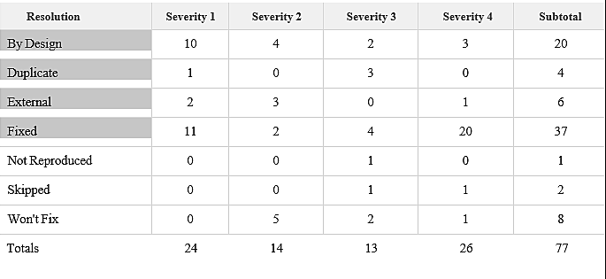

#### Test Case Analysis

This report shows the number of test cases that have passed, failed, and untested

|  |  |  |  |  |
| --- | --- | --- | --- | --- |
| **Section** | **Total Cases** | **Not Tested** | **Fail** | **Pass** |
| Print Engine | 7 | 0 | 0 | 7 |
| Client Application | 51 | 0 | 0 | 51 |
| Security | 2 | 0 | 0 | 2 |
| Outsource Shipping | 3 | 0 | 0 | 3 |
| Exception Reporting | 9 | 0 | 0 | 9 |
| Final Report Output | 4 | 0 | 0 | 4 |
| Version Control | 2 | 0 | 0 | 2 |

**9.RESULTS**

**1.PERFORMANCE METRICS**

* 1. Hours worked: 50 hours
  2. Stick to Timelines: 100%
  3. Stay within budget: 100%
  4. Consistency of the product: 85%
  5. Efficiency of the product: 85%
  6. Quality of the product: 85%

Through this approach, the early findings of the data analysis to find the essential underlying patterns for forecasting cardiac illnesses are presented. Age, the type of chest discomfort, blood pressure, and blood sugar level are factors used in tests to predict heart disease based on information gathered from patients. The K-means technique is then used to put the pre- processed heart disease data set together. With the help of machine learning algorithms and data mining techniques, this initiative aims to forecast cardiac disease. In the study, the random forest algorithm was utilised to forecast the development of heart disease in patients. To verify the accuracy of these rules, a group of significant feature scopes and rules were found in the diagnosis of heart disease.

**10.ADVANTAGES & DISADVANTAGES:**

**ADVANTAGES:**

* Smooth User Interface
* Accuracy is achieved quickly

As we are using the patient's or person's pre-existing data, it forecasts the likelihood of illnesses and categorises the patient depending on risk level. Because of this prognosis, patients can met with the appropriate doctor as a preventative action and be mentally free of worries about condition.

**DISADVANTAGES:**

Random forest can be used for both classification and regression tasks, butt is not more suitable for Regression tasks.

Swelling, lightheadedness, and other symptoms that can impair daily activities can appear in people with heart failure. A person with heart disease who has been diagnosed must also deal with the anxiety of having a chronic illness that could cause a cardiac event, such as a heart attack or stroke. Patients with a history of CVD may have a range of physical and psychological symptoms, including fatigue, edoema, and sleeping issues. These symptoms might limit their participation in physical and social activities, which lowers their quality of life.

**11.CONCLUSION:**

This overview of the project conveys the idea that numerous methods have been investigated for diagnosing cardiovascular disease. Big data, machine learning, and data mining can be used to great success to analyse the prediction model with the highest degree of accuracy. The primary goal of this project is to diagnose cardiovascular disease or heart disease utilizing a variety of techniques and procedures to obtain a prognosis.

**12.FUTURE SCOPE**

A future update shall comprise of section for viewing renowned cardiologists and scan centers in their city. The obtained output can be further processed and sent to smart devices to provide necessary assistance. Constant monitoring can provide necessary data to recommend to consult a doctor in case of an emergency.

#### APPENDIX: SOURCE CODE:

**app.py:**

import numpy as np import pickle import sklearn

from flask import Flask, render_template, request, redirect, url_for, flash import sqlite3

model = pickle.load(open('models.pkl', 'rb')) app = Flask( name )

app.secret_key = "7847541"

def get_db():

conn = sqlite3.connect('user_details.db') conn.row_factory = sqlite3.Row

return conn @app.route('/') def index():

return render_template('index.html', title='Home')

@app.route('/about') def about():

return render_template('about.html', title='About')

@app.route('/signin', methods=('GET', 'POST')) def signin():

error = None

if request.method == 'POST': name = request.form['name']

password = request.form['password'] db = get_db()

user = db.execute(

'SELECT name FROM user_details WHERE password = ?', (password, )

).fetchone()

if user is None:

error = 'Incorrect Username/Password.'

if error is None:

return render_template('index.html', title="Home", succ="login successfull!")

flash(error) db.close()

return render_template('signin.html', title='Sign In', error=error)

@app.route('/signup', methods=('POST', 'GET'))

def signup():

if request.method == 'POST': name = request.form['name'] email = request.form['email']

password = request.form['password'] db = get_db()

curr = db.cursor() curr.execute(

'INSERT INTO user_details (name, email, password) VALUES (?, ?, ?

);',

(name, email, password )

)

db.commit() curr.close() db.close()

return render_template('index.html', title="Home", succ="Registration Successfull!")

return render_template('signup.html', title='Sign Up')

@app.route('/Heart_Disease_Classifier') def Heart_Disease_Classifier():

return render_template('Heart_Disease_Classifier.html')

@app.route('/predict', methods =['POST']) def predict():

features = [float(i) for i in request.form.values()] #Convert features to array

array_features = [np.array(features)] #Predict features

prediction = model.predict(array_features)

output = prediction if output == 1:

return render_template('Heart_Disease_Classifier.html', result = 'The patient is not likely

to have heart disease!') else:

return render_template('Heart_Disease_Classifier.html', result = 'The patient is likely to have

heart disease!')

if name == ' main ':

debug(True)

**PREDICTION:**

<html>

<head>

<!-- Bootstrap CSS -->

<link rel="stylesheet" href="https://stackpath.bootstrapcdn.com/bootstrap/4.5.2/css/bootstrap.min.css" integrity="sha384- JcKb8q3iqJ61gNV9KGb8thSsNjpSL0n8PARn9HuZOnIxN0hoP+VmmDGMN5t9UJ0Z" crossorigin="anonymous">

<script src="https://code.jquery.com/jquery-3.5.1.slim.min.js" integrity="sha384- DfXdz2htPH0lsSSs5nCTpuj/zy4C+OGpamoFVy38MVBnE+IbbVYUew+OrCXaRkfj" crossorigin="anonymous"></script>

<script [src="https://cdn.jsdelivr.net/npm/popper.js@1.16.1/dist/umd/popper.min.js"](https://cdn.jsdelivr.net/npm/popper.js%401.16.1/dist/umd/popper.min.js) integrity="sha384-9/reFTGAW83EW2RDu2S0VKaIzap3H66lZH81PoYlFhbGU+6BZp6G7niu735Sk7lN" crossorigin="anonymous"></script>

<script src="https://stackpath.bootstrapcdn.com/bootstrap/4.5.2/js/bootstrap.min.js" integrity="sha384-B4gt1jrGC7Jh4AgTPSdUtOBvfO8shuf57BaghqFfPlYxofvL8/KUEfYiJOMMV+rV" crossorigin="anonymous"></script>

<title>Heart Disease Test</title>

</head>

<body>

<!-- Java Script -->

<script src="https://code.jquery.com/jquery-3.5.1.slim.min.js" integrity="sha384- DfXdz2htPH0lsSSs5nCTpuj/zy4C+OGpamoFVy38MVBnE+IbbVYUew+OrCXaRkfj" crossorigin="anonymous"></script>

<script [src="https://cdn.jsdelivr.net/npm/popper.js@1.16.1/dist/umd/popper.min.js"](https://cdn.jsdelivr.net/npm/popper.js%401.16.1/dist/umd/popper.min.js) integrity="sha384-9/reFTGAW83EW2RDu2S0VKaIzap3H66lZH81PoYlFhbGU+6BZp6G7niu735Sk7lN" crossorigin="anonymous"></script>

<script src="https://stackpath.bootstrapcdn.com/bootstrap/4.5.2/js/bootstrap.min.js" integrity="sha384-B4gt1jrGC7Jh4AgTPSdUtOBvfO8shuf57BaghqFfPlYxofvL8/KUEfYiJOMMV+rV" crossorigin="anonymous"></script>

<!-- Navbar-->

<nav class="navbar navbar-dark" style="background-color: rgb(13, 102, 87);">

<span class="navbar-brand mb-0 h1">Heart Disease Test</span>

</nav>

<div class="container">

<br>

<!--Form-->

<form action = "{{url_for('predict')}}" method ="POST" >

<fieldset>

<legend style="color: rgb(41, 15, 134);"><b>Heart Disease Test Form</b></legend><br>

<div class="card card-body" style="background-color: rgb(194 245 236 / 56%);">

<div class="form-group row">

<div class="col-sm-3">

<label for="age">Age</label>

<input type="number" class="form-control" id="age" name="age" required>

</div>

<div class="col-sm-3">

<label for="sex">Sex</label>

<select class="form-control" id="sex" name="sex" required>

<option disabled selected value> -- Select an Option -- </option>

<option value = "0">Female</option>

<option value = "1">Male</option>

</select>

</div>

</div>

<br>

<div class="form-group row">

<div class="col-sm">

<label for="cp">Chest Pain Type</label>

<select class="form-control" id="cp"

name = "cp" required>

required>

required>

name="fbs" required>

<option disabled selected value> -- Select an Option -- </option>

<option value = "1">Typical Angina</option>

<option value = "2">Atypical Angina</option>

<option value = "3">Non-anginal Pain</option>

<option value = "4">Asymptomatic</option>

</select>

</div>

<div class="col-sm">

<label for="trestbps">Resting Blood Pressure in mm Hg</label>

<input type="number" class="form-control" id="trestbps" name="trestbps"

</div>

<div class="col-sm">

<label for="chol">Serum Cholesterol in mg/dl</label>

<input type="number" class="form-control" id="chol" name="chol"

</div>

<div class="col-sm">

<label for="fbs">Fasting Blood Sugar > 120 mg/dl</label>

<select class="form-control" id="fbs"

<option disabled selected value> -- Select an Option -- </option>

<option value = "0">False</option>

<option value = "1">True</option>

</select>

</div>

</div>

</label>

<br>

<div class="form-group row">

<div class="col-sm">

<label for="restecg">Resting ECG Results

<select class="form-control" id="restecg" name="restecg" required>

<option disabled selected value> -- Select an Option -- </option>

<option value = "0">Normal </option>

<option value = "1">

Having ST-T wave abnormality </option>

<option value = "2">Probable or definite left ventricular

hypertrophy</option>

name="thalach" required>

</label>

</label>

name="oldpeak" required>

</select>

</div>

<div class="col-sm">

<label for="thalach">Maximum Heart Rate</label>

<input type="number" class="form-control" id="thalach"

</div>

<div class="col-sm">

<label for="exang">Exercise Induced Angina

<select class="form-control" id="exang" name="exang" required>

<option disabled selected value> -- Select an Option -- </option>

<option value = "0">No</option>

<option value = "1">Yes</option>

</select>

</div>

<div class="col-sm">

<label for="oldpeak">ST Depression Induced

<input type="number" step="any" class="form-control" id="oldpeak"

</div>

ST Segment </label>

</div>

<br>

<div class="form-group row">

<div class="col-sm">

<label for="slope">Slope of the Peak Exercise

<select class="form-control" id="slope" name="slope" required>

<option disabled selected value> -- Select an Option -- </option>

required>

<option value = "1">Upsloping</option>

<option value = "2">Flat</option>

<option value = "3">Downsloping</option>

</select>

</div>

<div class="col-sm">

<label for="ca">Number of Vessels Colored by Flourosopy</label>

<select class="form-control" id="ca" name = "ca"

<option disabled selected value> -- Select an Option -- </option>

<option value = "0">0</option>

<option value = "1">1</option>

<option value = "2">2</option>

<option value = "3">3</option>

</select>

</div>

<div class="col-sm">

<label for="thal">Thalassemia</label>

<select class="form-control" id="thal" name = "thal" required>

<option disabled selected value> -- Select an Option -- </option>

<option value = "3">Normal</option>

<option value = "6">Fixed defect</option>

<option value = "7">Reversable defect</option>

</select>

</div>

</div>

<br>

<div class="form-group">

<input class="btn btn-primary" type="submit" value="Result">

</div>

<!--Prediction Result-->

<div id ="result">

<strong style="color:red">{{result}}</strong>

</div>

</div>

</fieldset>

</form>

</div>

</body>

</html>

}

#### GITHUB LINK:

<https://github.com/IBM-EPBL/IBM-Project-1691-1658409938>

#### DEMO LINK:

<https://drive.google.com/file/d/1eH6GlyWQ1qZJK_CUU0unpZkV05PirZzy/view?usp=share_link>